Honk, Rattle, and Roll's Next Dine-Out Event!

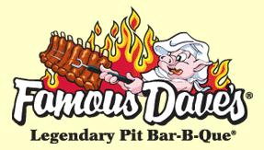

Join us Tuesday, Feb 8 at 6pm at Famous Dave’s

991 Industrial Blvd., Smyrna 37086

Please take special note - We will be meeting at 6:00. This is a time change for all 2022 club dine-outs

Gratuity May or may not be added so check your bill and tip accordingly. Please tip generously.

Please RSVP by February 4th of how many in your party will attend. I will need to call and give them a headcount. [Eakathy@bellsouth.net](mailto:Eakathy@bellsouth.net)

You may also e-mail Tom Vasser at [tomvasser@yahoo.com](mailto:tomvasser@yahoo.com) to RSVP by February 4

Thanks Kathy Warlick